News & Notes—Week of June 28th to July 4th, 2026
Church Contacts: Pastor Steve Meyer: (507) 725-3123 / 507-459-7623(cell) or pastormeyer@acegroup.cc
Church Office: Sarah Klug (507) 725-3123 or churchoffice@acegroup.cc
Church Organist/Choir Director, Emily Riley: (507) 725-3123 or rileem01@gmail.com
Find Us Online: http://www.immanuelcaledonia.org or www.facebook.com/immanuelcaledonia
YouTube: https://www.youtube.com/channel/UC7WKKOvVAt7fZn2v5_Mgwsg

Sunday 28 | Monday 29 | Tuesday 30 | Wednesday 1 | Thursday 2 | Friday 3 | Saturday 4
-9:00am: Worship  -4pm-7pm: Church Picnic at Beaver State Park | - 8:30am-2pm Office open  -Pastor back  -11:30am-1:00pm Summer Eats | - 8:30am-2pm Office open | - 11am-2:30pm Office open  -11:30am-1:00pm Summer Eats | -8:00am: Bulletin Submission Deadline | - 8:30am-2pm Office open  -11:30am-1:00pm Summer Eats |     
This Week at Immanuel
Birthdays this Week: McKenna Eglinton, Gabriel Curley, Blake Peterson, Arnold Meisch, and Sharlene Schroeder. Happy Birthday everyone!

Remembering Those who Died within the Last 20 Years: Pauline Schmoll, Lucille Burmeister, Michael Steele, and Dr. Aanon Rolf Jore.

Please lift up in prayer: Emily Douglas, Patricia Holdmeyer (mother of Ryan Holdmeyer), Tim Schroeder, Gayle Grippen, Karen Meiners, Roger Vick, Tom Danielson, Orville Larson (Grandpa of Emily Riley), Don Zoubek (Uncle to Geoff Mell), Rachel Storlie, Donna Schulze, John Stange (cousin to Pastor), Gladys Tegtmeier (moved to Claddagh), Carol Meiners (Valley View Nursing Home), and Phyllis Duxbury (Home).
If you would like a prayer request to be added, please contact the church office.

Watch this space for Summer Eats updates weekly!
Week 6 (the week of July 6) Summer Eats will be looking for apples, baby carrots, (red, yellow, and orange) bell peppers, and Little Debbie Red, White, and Blue snack cakes or brownies.
Summer Eats can always use peanut butter and jelly (grape and strawberry). While we love the homemade jams and jellies unfortunately they cannot be used for this program.
All donations are welcome.
More volunteers on July 3, July 6, July 10, July 13, and July 17 are also needed. Email or talk to Tricia, Jan, Grace, or the Church office. You can email immanuelsummereats@gmail.com with any questions.

HAPPENING TODAY
Church Picnic Gathering at Beaver Creek State Park - Sunday, June 28th: The Engaging Children Initiative (ECI) Task Force is hosting a picnic at the park shelter at Beaver Creek from 4pm until 7pm. A meal will be served at 5pm with worship at 6:30pm. Park passes are required for Beaver Creek State Park, they are $7 and available online ahead of time or at the park as you enter. If you would like to carpool or need help with Beaver park access, please contact the church office. The park passes at the library are reserved for this event as well. The shelter where the event is going to be held is a short walk on a paved path from the parking lot, wheelchairs will be available if anyone needs assistance getting to the shelter. PLEASE DON’T FORGET YOUR LAWN CHAIRS!

WELCA Baby Kit Donations: Are you a Kohl’s shopper and have unused Kohl’s Cash available? Please consider using your Kohl’s Cash for essential WELCA baby kit items. Items urgently needed are socks and t-shirts size 6 months – 24 months/2T (note that NO camouflage, religious symbols, flags, patriotic or military symbols, or references to the armed forces are allowed). Lutheran World Relief now requires 2 new pairs of socks for each baby kit. Please leave the items in the WELCA containers under the church mailbox. Thank you!
WELCA Flannel Sheets and Pillowcases Donations: WELCA members are looking for gently used flannel sheets of any size (both fitted and flat) and flannel pillowcases. These linens will be made into diapers for mission baby kits, with each kit containing 4 diapers. Please leave the linens in the WELCA containers under the church mailbox. Thank you!

Summer Sunday School- What A Mess!: New this summer, once a month from May to August, Summer Sunday School will be during the church service like our traditional Sunday School Program. The theme is "What a Mess!" where we'll be talking about why the world is so messy and how Jesus loves messy people! And it wouldn't be complete without messy projects!
July 12th - Confess Your Mess - Let's be honest about sin.
August 9th - Address Your Mess and Address Their Mess - His grace covers our sin and forgive like Jesus.
If you have confirmation aged kids, this will count towards confirmation requirements.
Explorers Day Camp at Sugar Creek Bible Camp
We will be headed back to Sugar Creek for Explorers Camp on Monday, July 20th! This one-day adventure will include Bible Story time and a variety of activities that includes fun games, nature time, swimming, crafts, pony time and exploring the camp valley! This will also be a great opportunity for our youth to experience Sugar Creek before considering an overnight program. Day campers must be entering Kindergarten through 6th grade to attend. An email with registration details will go to families. Please contact Stephanie Mell at stephmell1024@gmail.com for registration details if you do not get an email.

Update from Pastor Meyer: I will return to the office Monday morning. Recovery has gone well, and I continue to be on track with recovery. Recovery has gone much as it did with the first knee - with some nights of tossing and turning and other nights of good sleep. Thank you for this time for me to focus on my health and recovery. I also really appreciate the love and concern that you have shown during this time.

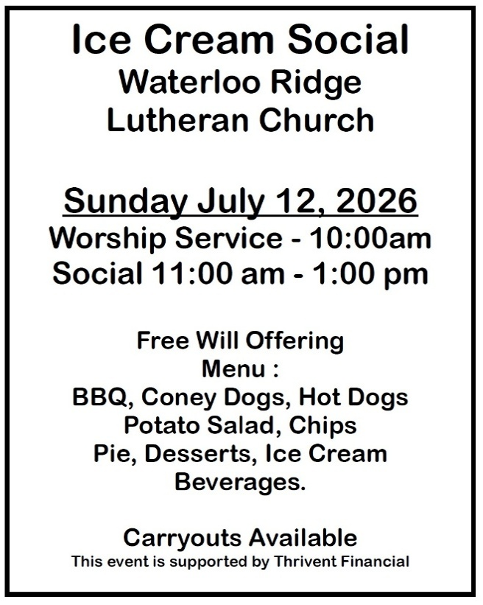
Thank you to:
Pastor Mark Jolivette for today’s service
and to all of today’s volunteers!

