Thirteenth Sunday after Pentecost
Immanuel Lutheran Church
August 23, 2026

Welcome to this place of praise and prayer. We gather today in celebration of the life, death and resurrection of Jesus Christ, as part of God’s family.
- We would appreciate having you sign our guest book so that we can remember your presence with us. Please note that in the ELW the page numbers are printed at the bottom of the page and hymn numbers are located at the top. The order of worship is outlined on the following pages.
- The offering reminds us that all of life is a gift of God. We are stewards of that gift. In response, a portion of our income is given as an act of worship to do God’s work in the world. Immanuel is a first-fruits congregation. That means that every Sunday when the offering is taken in, we give first to the mission and the ministry of the ELCA. We don’t wait to see if we can pay our bills before we give away for God’s mission. It is our hands doing God’s work, for the sake of the world our Lord loves.
- We serve Holy Communion on the first Sunday of the month and at all festivals. We offer an open invitation to all baptized believers to participate. It is our understanding that Christ offers his body and blood with the bread and wine to forgive sin and strengthen faith and life. If you receive communion in your home church, you are welcome to receive communion here.
- We have a toddler worship area in the middle-right section of our pews. This area is intended for children ages 0-3 accompanied by an adult(s) to sit during worship. Children 4K-6th Grade are welcome to join us for Sunday school during worship downstairs. This is a space for families to be fully engaged in worship, while providing quiet activities for young children to accommodate their natural need to move and be busy. Please follow posted guidelines for use of this space. Thank you!
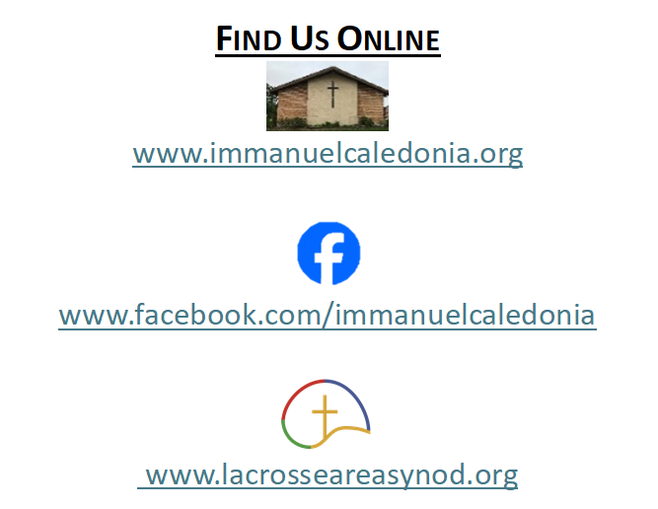
- We have accommodated seating available in the middle-left and the front-right sections of our pews. Please feel free to utilize this space for those who may need it!
Contact Information
Rev. Steven E. Meyer
pastormeyer@acegroup.cc
507-725-3123 or 507-459-7623 (cell)

Church Office: Sarah Klug
churchoffice@acegroup.cc
507-725-3123

Organist/Choir Director, Emily Riley
rileem01@gmail.com

Copyright permissions: Liturgical Text & Music; From Sundaysandseasons.com Copyright© 2026 Augsburg Fortress
Church Copyright License #23044886; Church Streaming License #23044893

GATHERING
The Holy Spirit calls us together as the people of God.
Prelude

Welcome and Worship Announcements
*Please note all bold text throughout the service are congregational responses

(Please stand as you are able)
Confession and Forgiveness

Blessed be the holy Trinity,☩ one God,
whose compassion endures forever.
Amen.

Let us confess our sin to God.

(Silence is kept for reflection)

Compassionate God,
we confess to you all our sins.
Our burden is heavy, and we cannot free ourselves.
In your mercy, call us back to you.
Your yoke is easy and your burden is light.
Restore us to dwell in your peace.
In Christ’s name we pray,
Amen.

Jesus says, “Come to me,
all you who are weary
and are carrying heavy burdens,
and I will give you rest.”
In the name of God,
Father, ☩ Son, and Holy Spirit,
your sins are forgiven.
Rest in God’s love.
Amen.

Gathering Hymn Built on a Rock #652
BAPTISM
Baptism of Colson James Barnes Insert
Baptismal Hymn Baptized and Set Free #453

Prayer of the Day
O God, with all your faithful followers of every age, we praise you, the rock of our life. Be our strong foundation and form us into the body of your Son, that we may gladly minister to all the world, through Jesus Christ, our Savior and Lord. Amen.

Children’s Sermon
WORD
God speaks to us in scripture readings, preachings, and songs.

First Reading: Exodus 1:8-2:10

The brave Hebrew midwives defied Pharaoh to save many infants from death. When the mother of Moses placed him in a basket in the Nile, the daughter of Pharaoh found him, adopted him, and raised him. Moses’ sister and mother also played crucial roles in this drama.

⁸ Now a new king arose over Egypt who did not know Joseph. ⁹ He said to his people, “Look, the Israelite people are more numerous and more powerful than we. ¹⁰ Come, let us deal shrewdly with them, or they will increase and, in the event of war, join our enemies and fight against us and escape from the land.” ¹¹ Therefore they set taskmasters over them to oppress them with forced labor. They built supply cities, Pithom and Rameses, for Pharaoh. ¹² But the more they were oppressed, the more they multiplied and spread, so that the Egyptians came to dread the Israelites. ¹³ The Egyptians subjected the Israelites to hard servitude ¹⁴ and made their lives bitter with hard servitude in mortar and bricks and in every kind of field labor. They were ruthless in all the tasks that they imposed on them.
¹⁵ The king of Egypt said to the Hebrew midwives, one of whom was named Shiphrah and the other Puah, ¹⁶ “When you act as midwives to the Hebrew women and see them on the birthstool, if it is a son, kill him, but if it is a daughter, she shall live.” ¹⁷ But the midwives feared God; they did not do as the king of Egypt commanded them, but they let the boys live. ¹⁸ So the king of Egypt summoned the midwives and said to them, “Why have you done this and allowed the boys to live?” ¹⁹ The midwives said to Pharaoh, “Because the Hebrew women are not like the Egyptian women, for they are vigorous and give birth before the midwife comes to them.” ²⁰ So God dealt well with the midwives, and the people multiplied and became very strong. ²¹ And because the midwives feared God, he gave them families. ²² Then Pharaoh commanded all his people, “Every son that is born to the Hebrews you shall throw into the Nile, but you shall let every daughter live.”
2:¹ Now a man from the house of Levi went and married a Levite woman. ² The woman conceived and bore a son, and when she saw that he was a fine baby, she hid him three months. ³ When she could hide him no longer she got a papyrus basket for him and plastered it with bitumen and pitch; she put the child in it and placed it among the reeds on the bank of the river. ⁴ His sister stood at a distance, to see what would happen to him.
⁵ The daughter of Pharaoh came down to bathe at the river, while her attendants walked beside the river. She saw the basket among the reeds and sent her maid to bring it. ⁶ When she opened it, she saw the child. He was crying, and she took pity on him. “This must be one of the Hebrews’ children,” she said. ⁷ Then his sister said to Pharaoh’s daughter, “Shall I go and get you a nurse from the Hebrew women to nurse the child for you?” ⁸ Pharaoh’s daughter said to her, “Yes.” So the girl went and called the child’s mother. ⁹ Pharaoh’s daughter said to her, “Take this child and nurse it for me, and I will give you your wages.” So the woman took the child and nursed it. ¹⁰ When the child grew up, she brought him to Pharaoh’s daughter, and he became her son. She named him Moses, “because” she said, “I drew him out of the water.”

The Word of the Lord. Thanks be to God!

(Please stand as you are able)
Gospel Acclamation Page 142

Gospel Reading: Matthew 16:13-20

The holy gospel according to Matthew, chapter 16. Glory to you, O Lord.

At a climactic point in Jesus’ ministry, God reveals to Peter that Jesus is “the Messiah, the Son of the living God,” and Jesus responds with the promise of a church that will overcome the very gates of Hades.

¹³ Now when Jesus came into the district of Caesarea Philippi, he asked his disciples, “Who do people say that the Son of Man is?” ¹⁴ And they said, “Some say John the Baptist but others Elijah and still others Jeremiah or one of the prophets.” ¹⁵ He said to them, “But who do you say that I am?” ¹⁶ Simon Peter answered, “You are the Messiah, the Son of the living God.” ¹⁷ And Jesus answered him, “Blessed are you, Simon son of Jonah! For flesh and blood has not revealed this to you but my Father in heaven. ¹⁸ And I tell you, you are Peter, and on this rock I will build my church, and the gates of Hades will not prevail against it. ¹⁹ I will give you the keys of the kingdom of heaven, and whatever you bind on earth will be bound in heaven, and whatever you loose on earth will be loosed in heaven.” ²⁰ Then he sternly ordered the disciples not to tell anyone that he was the Messiah.

This is the gospel of our Lord. Praise to you, O Christ!

(Congregation may be seated)
Sermon

Hymn of the Day O Savior, Precious Savior #820

Prayers of the People
The response to each prayer will be, “Merciful God,”
Congregations reply will be, “receive our prayer.”

Sharing of the Peace
The peace of Christ be with you always.
And also with you.
You are welcome to send a text or email to share peace with others.

Offering
(Offerings may be placed in the wooden offering box as you leave the sanctuary)

Offering Response We Are an Offering #692

Offering Prayer
Loving God, we offer at your table the gifts of our hearts. Help us take heart in you and share freely of your love, so that all creation can taste your abundance. We ask this in the name of Jesus, through the Spirit abiding with us now and forever. Amen.

The Lord’s Prayer
Our Father, who art in heaven, hallowed be thy name, thy kingdom come, thy will be done, on earth as it is in heaven. Give us this day our daily bread. And forgive us our trespasses, as we forgive those who trespass against us. And lead us not into temptation but deliver us from evil. For thine is the kingdom, and the power, and the glory, for ever and ever. Amen.

SENDING
God blesses us and sends us in mission for the world.
Benediction

Announcements

Sending Hymn My Hope Is Built on Nothing Less #597

Dismissal
Go in peace. You are the body of Christ.
Thanks be to God.

Postlude
Thank you to today’s volunteers!
Greeters:
Ushers: Dave Renslo and
Dean Schutte
Reader: Stacey Meyer
Live Streamer: Cheryl K.
Presentation Clicker:
Coffee and Fellowship Provided by:

A special thank you to Holly Becker for playing for us today!
Also, thank you to anyone who stepped into the blank spaces today and helped
today’s service run smoothly! We truly couldn’t do this without our amazing members!

