Twelfth Sunday after Pentecost
Immanuel Lutheran Church
August 16, 2026

Welcome to this place of praise and prayer. We gather today in celebration of the life, death and resurrection of Jesus Christ, as part of God’s family.
- We would appreciate having you sign our guest book so that we can remember your presence with us. Please note that in the ELW the page numbers are printed at the bottom of the page and hymn numbers are located at the top. The order of worship is outlined on the following pages.
- The offering reminds us that all of life is a gift of God. We are stewards of that gift. In response, a portion of our income is given as an act of worship to do God’s work in the world. Immanuel is a first-fruits congregation. That means that every Sunday when the offering is taken in, we give first to the mission and the ministry of the ELCA. We don’t wait to see if we can pay our bills before we give away for God’s mission. It is our hands doing God’s work, for the sake of the world our Lord loves.
- We serve Holy Communion on the first Sunday of the month and at all festivals. We offer an open invitation to all baptized believers to participate. It is our understanding that Christ offers his body and blood with the bread and wine to forgive sin and strengthen faith and life. If you receive communion in your home church, you are welcome to receive communion here.
- We have a toddler worship area in the middle-right section of our pews. This area is intended for children ages 0-3 accompanied by an adult(s) to sit during worship. Children 4K-6th Grade are welcome to join us for Sunday school during worship downstairs. This is a space for families to be fully engaged in worship, while providing quiet activities for young children to accommodate their natural need to move and be busy. Please follow posted guidelines for use of this space. Thank you!
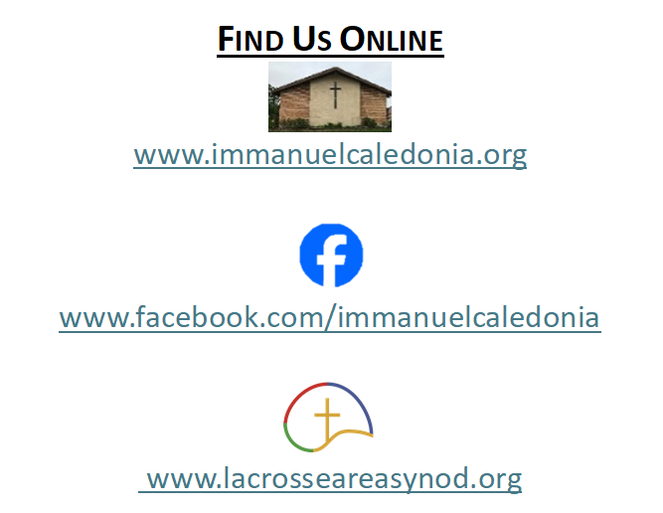
- We have accommodated seating available in the middle-left and the front-right sections of our pews. Please feel free to utilize this space for those who may need it!
Contact Information
Rev. Steven E. Meyer
pastormeyer@acegroup.cc
507-725-3123 or 507-459-7623 (cell)

Church Office: Sarah Klug
churchoffice@acegroup.cc
507-725-3123

Organist/Choir Director, Emily Riley
rileem01@gmail.com

Copyright permissions: Liturgical Text & Music; From Sundaysandseasons.com Copyright© 2026 Augsburg Fortress
Church Copyright License #23044886; Church Streaming License #23044893

GATHERING
The Holy Spirit calls us together as the people of God.

Prelude

Welcome and Worship Announcements
*Please note all bold text throughout the service are congregational responses

(Please stand as you are able)
Confession and Forgiveness

Blessed be the holy Trinity,☩ one God,
whose compassion endures forever.
Amen.

Let us confess our sin to God.

(Silence is kept for reflection)

Compassionate God,
we confess to you all our sins.
Our burden is heavy, and we cannot free ourselves.
In your mercy, call us back to you.
Your yoke is easy and your burden is light.
Restore us to dwell in your peace.
In Christ’s name we pray,
Amen.

Jesus says, “Come to me,
all you who are weary
and are carrying heavy burdens,
and I will give you rest.”
In the name of God,
Father, ☩ Son, and Holy Spirit,
your sins are forgiven.
Rest in God’s love.
Amen.

Gathering Hymn In Christ There Is No East or West #650
Greeting
The grace of our Lord Jesus Christ, the love of God, and the communion of the Holy Spirit be with you all.
And also with you.

Kyrie (Spoken) Page 138

Hymn of Praise Glory to God Page 139

Prayer of the Day
God of all peoples, your arms reach out to embrace all those who call upon you. Teach us as disciples of your Son to love the world with compassion and constancy, that your name may be known throughout the earth, through Jesus Christ, our Savior and Lord.
Amen.

WORD
God speaks to us in scripture readings, preaching, and song

First Reading: Genesis 45: 1-15

Moved to tears by Judah’s plea on behalf of Benjamin, Joseph declares, “I am Joseph!” and asks, “Is my father still alive?” Despite the brothers’ evil intent, God used Joseph to preserve many lives at a time of famine.

After Judah offered himself in place of his brother Benjamin, ¹ Joseph could no longer control himself before all those who stood by him, and he cried out, “Send everyone away from me.” So no one stayed with him when Joseph made himself known to his brothers. ² And he wept so loudly that the Egyptians heard it, and the household of Pharaoh heard it. ³ Joseph said to his brothers, “I am Joseph. Is my father still alive?” But his brothers could not answer him, so dismayed were they at his presence.
⁴ Then Joseph said to his brothers, “Come closer to me.” And they came closer. He said, “I am your brother, Joseph, whom you sold into Egypt. ⁵ And now do not be distressed or angry with yourselves because you sold me here, for God sent me before you to preserve life. ⁶ For the famine has been in the land these two years, and there are five more years in which there will be neither plowing nor harvest. ⁷ God sent me before you to preserve for you a remnant on earth and to keep alive for you many survivors. ⁸ So it was not you who sent me here but God; he has made me a father to Pharaoh and lord of all his house and ruler over all the land of Egypt. ⁹ Hurry and go up to my father and say to him, ‘Thus says your son Joseph, God has made me lord of all Egypt; come down to me; do not delay. ¹⁰ You shall settle in the land of Goshen, and you shall be near me, you and your children and your children’s children, as well as your flocks, your herds, and all that you have. ¹¹ I will provide for you there, since there are five more years of famine to come, so that you and your household and all that you have will not come to poverty.’ ¹² And now your eyes and the eyes of my brother Benjamin see that it is my own mouth that speaks to you. ¹³ You must tell my father how greatly I am honored in Egypt and all that you have seen. Hurry and bring my father down here.” ¹⁴ Then he fell upon his brother Benjamin’s neck and wept, while Benjamin wept upon his neck. ¹⁵ And he kissed all his brothers and wept upon them, and after that his brothers talked with him.

The Word of the Lord. Thanks be to God!

(Please stand as you are able)
Gospel Acclamation Page 142

Gospel Reading: Matthew 15: 10-28

The holy gospel according to Matthew, chapter 15. Glory to you, O Lord.

Jesus teaches his disciples that true purity is a matter of the heart rather than outward religious observances. Almost immediately, this teaching is tested when a woman considered to be a religious outsider approaches him for help.

¹⁰ Jesus called the crowd to him and said to them, “Listen and understand:¹¹ it is not what goes into the mouth that defiles a person, but it is what comes out of the mouth that defiles.” ¹² Then the disciples approached and said to him, “Do you know that the Pharisees took offense when they heard what you said?” ¹³ He answered, “Every plant that my heavenly Father has not planted will be uprooted. ¹⁴ Let them alone; they are blind guides of the blind. And if one blind person guides another, both will fall into a pit.” ¹⁵ But Peter said to him, “Explain this parable to us.” ¹⁶ Then he said, “Are you also still without understanding? ¹⁷ Do you not see that whatever goes into the mouth enters the stomach and goes out into the sewer? ¹⁸ But what comes out of the mouth proceeds from the heart, and this is what defiles. ¹⁹ For out of the heart come evil intentions, murder, adultery, sexual immorality, theft, false witness, slander. ²⁰ These are what defile a person, but to eat with unwashed hands does not defile.”
²¹ Jesus left that place and went away to the district of Tyre and Sidon. ²² Just then a Canaanite woman from that region came out and started shouting, “Have mercy on me, Lord, Son of David; my daughter is tormented by a demon.” ²³ But he did not answer her at all. And his disciples came and urged him, saying, “Send her away, for she keeps shouting after us.” ²⁴ He answered, “I was sent only to the lost sheep of the house of Israel.” ²⁵ But she came and knelt before him, saying, “Lord, help me.” ²⁶ He answered, “It is not fair to take the children’s food and throw it to the dogs.” ²⁷ She said, “Yes, Lord, yet even the dogs eat the crumbs that fall from their masters’ table.” ²⁸ Then Jesus answered her, “Woman, great is your faith! Let it be done for you as you wish.” And her daughter was healed from that moment.

This is the gospel of our Lord. Praise to you, O Christ!

(Congregation may be seated)
Sermon

Hymn of the Day Let Us Talents and Tongues Employ #674

Apostles’ Creed Page 105
Or Inside Back Cover of Hymnal
Prayers of the People
The response to each prayer will be, “Merciful God,”
Congregations reply will be, “receive our prayer.”

Sharing of the Peace
The peace of Christ be with you always.
And also with you.
You are welcome to send a text or email to share peace with others.

Offering
(Offerings may be placed in the wooden offering box as you leave the sanctuary)

Offering Response Create in Me a Clean Heart #186

Offering Prayer
Loving God, we offer at your table the gifts of our hearts. Help us take heart in you and share freely of your love, so that all creation can taste your abundance. We ask this in the name of Jesus, through the Spirit abiding with us now and forever. Amen.

The Lord’s Prayer
Our Father, who art in heaven, hallowed be thy name, thy kingdom come, thy will be done, on earth as it is in heaven. Give us this day our daily bread. And forgive us our trespasses, as we forgive those who trespass against us. And lead us not into temptation but deliver us from evil. For thine is the kingdom, and the power, and the glory, for ever and ever. Amen.

SENDING
God Blesses Us and Sends Us in Mission for the World.
Benediction

Announcements

Sending Hymn All People That on Earth Do Dwell #883

Dismissal
Go in peace. You are the body of Christ.
Thanks be to God.

Postlude
Thank you to today’s volunteers!
Greeters:
Ushers: Dave Renslo and
Dean Schutte
Reader: Jana Dittmer
Live Streamer: Nicole Flugge
Presentation Clicker:
Coffee and Fellowship Provided by:

Also a big thank you to Jason Knipe and to Paul Molling for filling in and helping with today’s service!

