Fifth Sunday after Pentecost
Immanuel Lutheran Church
June 28, 2026

Welcome to this place of praise and prayer. We gather today in celebration of the life, death and resurrection of Jesus Christ, as part of God’s family.
- We would appreciate having you sign our guest book so that we can remember your presence with us. Please note that in the ELW the page numbers are printed at the bottom of the page and hymn numbers are located at the top. The order of worship is outlined on the following pages.
- The offering reminds us that all of life is a gift of God. We are stewards of that gift. In response, a portion of our income is given as an act of worship to do God’s work in the world. Immanuel is a first-fruits congregation. That means that every Sunday when the offering is taken in, we give first to the mission and the ministry of the ELCA. We don’t wait to see if we can pay our bills before we give away for God’s mission. It is our hands doing God’s work, for the sake of the world our Lord loves.
- We serve Holy Communion on the first Sunday of the month and at all festivals. We offer an open invitation to all baptized believers to participate. It is our understanding that Christ offers his body and blood with the bread and wine to forgive sin and strengthen faith and life. If you receive communion in your home church, you are welcome to receive communion here.
- We have a toddler worship area in the middle-right section of our pews. This area is intended for children ages 0-3 accompanied by an adult(s) to sit during worship. Children 4K-6th Grade are welcome to join us for Sunday school during worship downstairs. This is a space for families to be fully engaged in worship, while providing quiet activities for young children to accommodate their natural need to move and be busy. Please follow posted guidelines for use of this space. Thank you!
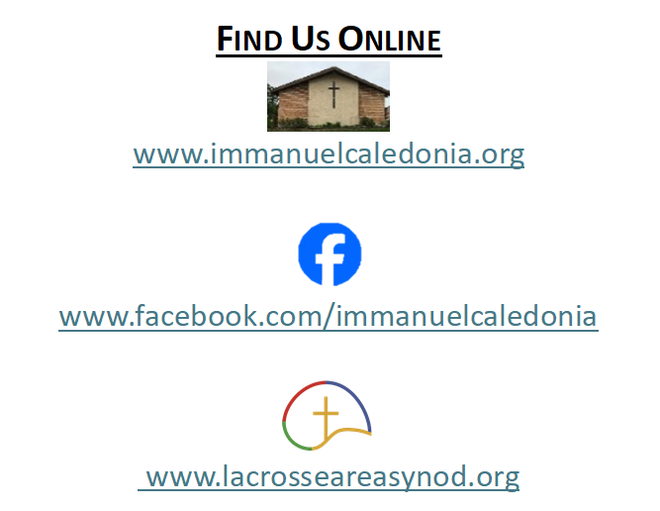
- We have accommodated seating available in the middle-left and the front-right sections of our pews. Please feel free to utilize this space for those who may need it!
Contact Information
Rev. Steven E. Meyer
pastormeyer@acegroup.cc
507-725-3123 or 507-459-7623 (cell)

Church Office: Sarah Klug
churchoffice@acegroup.cc
507-725-3123

Organist/Choir Director, Emily Riley
rileem01@gmail.com

Copyright permissions: Liturgical Text & Music; From Sundaysandseasons.com Copyright© 2026 Augsburg Fortress
Church Copyright License #23044886; Church Streaming License #23044893
GATHERING
The Holy Spirit calls us together as the people of God.
Prelude
Welcome And Worship Announcements
*Please note all bold text throughout the service are congregational responses

(Please stand as you are able)
Confession and Forgiveness
Blessed be the holy Trinity,☩ one God,
whose compassion endures forever.
Amen.
Let us confess our sin to God.
(Silence is kept for reflection)
Compassionate God,
we confess to you all our sins.
Our burden is heavy, and we cannot free ourselves.
In your mercy, call us back to you.
Your yoke is easy and your burden is light.
Restore us to dwell in your peace.
In Christ’s name we pray,
Amen.
Jesus says, “Come to me,
all you who are weary
and are carrying heavy burdens,
and I will give you rest.”
In the name of God,
Father, ☩ Son, and Holy Spirit,
your sins are forgiven.
Rest in God’s love.
Amen.
Gathering Hymn Lord of Glory, You Have Bought Us #707
Greeting
The grace of our Lord Jesus Christ, the love of God, and the communion of the Holy Spirit be with you all.
And also with you.
Kyrie Page 165-166

Hymn of Praise To Be Your Presence #546

Prayer Of The Day
O God, you direct our lives by your grace, and your words of justice and mercy reshape the world. Mold us into a people who welcome your word and serve one another, through Jesus Christ, our Savior and Lord.
Amen.
WORD
God speaks to us in scripture readings, preaching, and song

First Reading: Genesis 22:1-14
Abraham was prepared to obey God’s command amid extreme contradiction: the child to be sacrificed is the very child through whom Abraham is to receive descendants. God acknowledged Abraham’s obedient faith, and Abraham offered a ram in the place of his son Isaac.

¹ God tested Abraham. He said to him, “Abraham!” And he said, “Here I am.” ² He said, “Take your son, your only son Isaac, whom you love, and go to the land of Moriah and offer him there as a burnt offering on one of the mountains that I shall show you.” ³ So Abraham rose early in the morning, saddled his donkey, and took two of his young men with him and his son Isaac; he cut the wood for the burnt offering and set out and went to the place in the distance that God had shown him. ⁴ On the third day Abraham looked up and saw the place far away. ⁵ Then Abraham said to his young men, “Stay here with the donkey; the boy and I will go over there; we will worship, and then we will come back to you.” ⁶ Abraham took the wood of the burnt offering and laid it on his son Isaac, and he himself carried the fire and the knife. And the two of them walked on together. ⁷ Isaac said to his father Abraham, “Father!” And he said, “Here I am, my son.” He said, “The fire and the wood are here, but where is the lamb for a burnt offering?” ⁸ Abraham said, “God himself will provide the lamb for a burnt offering, my son.” And the two of them walked on together.
⁹ When they came to the place that God had shown him, Abraham built an altar there and laid the wood in order. He bound his son Isaac and laid him on the altar on top of the wood. ¹⁰ Then Abraham reached out his hand and took the knife to kill his son. ¹¹ But the angel of the Lord called to him from heaven and said, “Abraham, Abraham!” And he said, “Here I am.”¹² [The angel] said, “Do not lay your hand on the boy or do anything to him, for now I know that you fear God, since you have not withheld your son, your only son, from me.”¹³ And Abraham looked up and saw a ram, caught in a thicket by its horns. Abraham went and took the ram and offered it up as a burnt offering instead of his son. ¹⁴ So Abraham called that place “The Lord will provide,” as it is said to this day, “On the mount of the Lord it shall be provided.”

The Word of the Lord. Thanks be to God!

Second Reading: Romans 6: 12-23
Sin is an enslaving power which motivates us to live self-serving, disobedient lives. Sin’s final payoff is death. We, however, have been set free from sin’s slavery to live obediently under God’s grace, whose end is the free gift of eternal life.

¹² Do not let sin reign in your mortal bodies, so that you obey their desires. ¹³ No longer present your members to sin as instruments of unrighteousness, but present yourselves to God as those who have been brought from death to life, and present your members to God as instruments of righteousness. ¹⁴ For sin will have no dominion over you, since you are not under law but under grace.
¹⁵ What then? Should we sin because we are not under law but under grace? By no means! ¹⁶ Do you not know that, if you present yourselves to anyone as obedient slaves, you are slaves of the one whom you obey, either of sin, which leads to death, or of obedience, which leads to righteousness? ¹⁷ But thanks be to God that you who were slaves of sin have become obedient from the heart to the form of teaching to which you were entrusted ¹⁸ and that you, having been set free from sin, have become enslaved to righteousness. ¹⁹ I am speaking in human terms because of your limitations. For just as you once presented your members as slaves to impurity and lawlessness, leading to even more lawlessness, so now present your members as slaves to righteousness, leading to sanctification.
²⁰ When you were slaves of sin, you were free in regard to righteousness. ²¹ So what fruit did you then gain from the things of which you now are ashamed? The end of those things is death. ²² But now that you have been freed from sin and enslaved to God, the fruit you have leads to sanctification, and the end is eternal life. ²³ For the wages of sin is death, but the free gift of God is eternal life in Christ Jesus our Lord.

The Word of the Lord. Thanks be to God!
(Please stand as you are able)
Gospel Acclamation Lord, I Lift Your Name on High #857

Gospel Reading: Matthew 10:40-42
When Jesus sends his disciples out as missionaries, he warns them of persecution and hardships they will face. He also promises to reward any who aid his followers and support their ministry.
The holy gospel according to Matthew, chapter 10. Glory to you, O Lord.

[Jesus said to the twelve:] ⁴⁰ “Whoever welcomes you welcomes me, and whoever welcomes me welcomes the one who sent me. ⁴¹ Whoever welcomes a prophet in the name of a prophet will receive a prophet’s reward, and whoever welcomes a righteous person in the name of a righteous person will receive the reward of the righteous, ⁴² and whoever gives even a cup of cold water to one of these little ones in the name of a disciple—truly I tell you, none of these will lose their reward.”
This is the gospel of our Lord. Praise to you, O Christ!
(Congregation may be seated)
Sermon

Hymn of the Day Lord, Speak to Us, That We May Speak #676

Apostles’ Creed Page 105
Or Inside Back Cover of Hymnal
Prayers of the People
The response to each prayer will be, “God of Grace,”
Congregations reply will be, “hear our prayer.”

Sharing of the Peace
The peace of Christ be with you always. And also with you.
You are welcome to send a text or email to share peace with others.

Offering
(Offerings may be placed in the wooden offering box as you leave the sanctuary)

Offering Response Goodness Is Stronger than Evil #721

Offering Prayer
Holy God, gracious and merciful, you bring forth food from the earth and nourish your whole creation. Turn our hearts toward those who hunger in any way, that all may know your care. Feed us now and prepare us to proclaim your mission of Justice in our communities and in the world, through Jesus Christ our strength. Amen.

The Lord’s Prayer
Our Father, who art in heaven, hallowed be thy name, thy kingdom come, thy will be done, on earth as it is in heaven. Give us this day our daily bread. And forgive us our trespasses, as we forgive those who trespass against us. And lead us not into temptation but deliver us from evil. For thine is the kingdom, and the power, and the glory, for ever and ever. Amen.

SENDING
God Blesses Us and Sends Us in Mission for the World.

Benediction

Announcements: Tricia Babinski

Sending Hymn This Is My Song #887

Dismissal
Go in peace. You are the body of Christ.
Thanks be to God.

Postlude

Thank you to today’s volunteers!
We would love to have your help during our worship service. Please sign up at the kiosk in the church narthex or on the church website under the sign-up link on the home page. Thank you!

