Day of Pentecost
Immanuel Lutheran Church
May 24, 2026

Welcome to this place of praise and prayer. We gather today in celebration of the life, death and resurrection of Jesus Christ, as part of God’s family.
- We would appreciate having you sign our guest book so that we can remember your presence with us. Please note that in the ELW the page numbers are printed at the bottom of the page and hymn numbers are located at the top. The order of worship is outlined on the following pages.
- The offering reminds us that all of life is a gift of God. We are stewards of that gift. In response, a portion of our income is given as an act of worship to do God’s work in the world. Immanuel is a first-fruits congregation. That means that every Sunday when the offering is taken in, we give first to the mission and the ministry of the ELCA. We don’t wait to see if we can pay our bills before we give away for God’s mission. It is our hands doing God’s work, for the sake of the world our Lord loves.
- We serve Holy Communion on the first Sunday of the month and at all festivals. We offer an open invitation to all baptized believers to participate. It is our understanding that Christ offers his body and blood with the bread and wine to forgive sin and strengthen faith and life. If you receive communion in your home church, you are welcome to receive communion here.
- We have a toddler worship area in the middle-right section of our pews. This area is intended for children ages 0-3 accompanied by an adult(s) to sit during worship. Children 4K-6th Grade are welcome to join us for Sunday school during worship downstairs. This is a space for families to be fully engaged in worship, while providing quiet activities for young children to accommodate their natural need to move and be busy. Please follow posted guidelines for use of this space. Thank you!
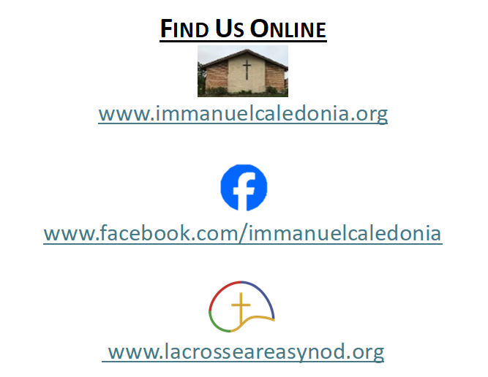
- We have accommodated seating available in the middle-left and the front-right sections of our pews. Please feel free to utilize this space for those who may need it!
Contact Information
Rev. Steven E. Meyer
pastormeyer@acegroup.cc
507-725-3123 or 507-459-7623 (cell)

Church Office: Sarah Klug
churchoffice@acegroup.cc
507-725-3123

Organist/Choir Director, Emily Riley
rileem01@gmail.com

Copyright permissions: Liturgical Text & Music; From Sundaysandseasons.com Copyright© 2026 Augsburg Fortress
Church Copyright License #23044886; Church Streaming License #23044893

GATHERING
The Holy Spirit calls us together as the people of God.
Prelude
Welcome And Worship Announcements
*Please note all bold text throughout the service are congregational responses
(Please stand as you are able)
Confession and Forgiveness
Blessed be the holy Trinity,☩ one God,
whose compassion endures forever.
Amen.
Let us confess our sin to God.
Silence is kept for reflection.
Compassionate God,
we confess to you all our sins.
Our burden is heavy, and we cannot free ourselves.
In your mercy, call us back to you.
Your yoke is easy and your burden is light.
Restore us to dwell in your peace.
In Christ’s name we pray,
Amen.
Jesus says, “Come to me,
all you who are weary
and are carrying heavy burdens,
and I will give you rest.”
In the name of God,
Father, ☩ Son, and Holy Spirit,
your sins are forgiven.
Rest in God’s love.
Amen.
Gathering Hymn Holy Spirit, Ever Dwelling #582

Greeting
The grace of our Lord Jesus Christ, the love of God, and the communion of the Holy Spirit be with you all.
And also with you.
Kyrie Page 138-139
Hymn of Praise This is the Feast Page 140-141

Prayer Of The Day
O God, on this day you open the hearts of your faithful people by sending into us your Holy Spirit. Direct us by the light of that Spirit, that we may have a right judgment in all things and rejoice at all times in your peace, through Jesus Christ, your Son and our Lord, who lives and reigns with you and the Holy Spirit, one God, now and forever. Amen.
WORD
God speaks to us in scripture readings, preaching, and song

First Reading: Acts 2:1-21
Pentecost was a Jewish harvest festival that marked the fiftieth day after Passover. Luke portrays the Holy Spirit being poured out upon the disciples before the gathered and astonished people assembled in Jerusalem for the festival. Filled with the Spirit, the disciples were able to witness to the power of Christ’s resurrection.

¹ When the day of Pentecost had come, [the apostles] were all together in one place. ² And suddenly from heaven there came a sound like the rush of a violent wind, and it filled the entire house where they were sitting. ³ Divided tongues, as of fire, appeared among them, and a tongue rested on each of them. ⁴ All of them were filled with the Holy Spirit and began to speak in other languages, as the Spirit gave them ability.
⁵ Now there were devout Jews from every people under heaven living in Jerusalem. ⁶ And at this sound the crowd gathered and was bewildered, because each one heard them speaking in the native language of each. ⁷ Amazed and astonished, they asked, “Are not all these who are speaking Galileans? ⁸ And how is it that we hear, each of us, in our own native language? ⁹ Parthians, Medes, Elamites, and residents of Mesopotamia, Judea and Cappadocia, Pontus and Asia, ¹⁰ Phrygia and Pamphylia, Egypt and the parts of Libya belonging to Cyrene, and visitors from Rome, both Jews and proselytes, ¹¹ Cretans and Arabs—in our own languages we hear them speaking about God’s deeds of power.” ¹² All were amazed and perplexed, saying to one another, “What does this mean?” ¹³ But others sneered and said, “They are filled with new wine.”
¹⁴ But Peter, standing with the eleven, raised his voice and addressed them, “Fellow Jews and all who live in Jerusalem, let this be known to you, and listen to what I say. ¹⁵ Indeed, these are not drunk, as you suppose, for it is only nine o’clock in the morning. ¹⁶ No, this is what was spoken through the prophet Joel:
¹⁷ ‘In the last days it will be, God declares,
that I will pour out my Spirit upon all flesh,
and your sons and your daughters shall prophesy,
and your young men shall see visions,
and your old men shall dream dreams.
¹⁸ Even upon my slaves, both men and women,
in those days I will pour out my Spirit,
and they shall prophesy.
¹⁹ And I will show portents in the heaven above
and signs on the earth below,
blood, and fire, and smoky mist.
²⁰ The sun shall be turned to darkness
and the moon to blood,
before the coming of the Lord’s great and glorious day.
²¹ Then everyone who calls on the name of the Lord shall be saved.’ ”
The Word of the Lord. Thanks be to God!

Second Reading: 1 Corinthians 12:3b-13
Paul is helping the Corinthians understand the relationship between our God-given unity and Spirit-created diversity. The Spirit creates the unity of faith and gives all Christians diverse gifts for the common benefit of all. We need one another’s diverse spiritual gifts because the same Spirit has given them to each person for the common good.

^{3b} No one can say “Jesus is Lord” except by the Holy Spirit.
⁴ Now there are varieties of gifts but the same Spirit, ⁵ and there are varieties of services but the same Lord, ⁶ and there are varieties of activities, but it is the same God who activates all of them in everyone. ⁷ To each is given the manifestation of the Spirit for the common good. ⁸ To one is given through the Spirit the utterance of wisdom and to another the utterance of knowledge according to the same Spirit, ⁹ to another faith by the same Spirit, to another gifts of healing by the one Spirit, ¹⁰ to another the working of powerful deeds, to another prophecy, to another the discernment of spirits, to another various kinds of tongues, to another the interpretation of tongues. ¹¹ All these are activated by one and the same Spirit, who allots to each one individually just as the Spirit chooses.
¹² For just as the body is one and has many members, and all the members of the body, though many, are one body, so it is with Christ. ¹³ For in the one Spirit we were all baptized into one body—Jews or Greeks, slaves or free—and we were all made to drink of one Spirit.
The Word of the Lord. Thanks be to God!

(Please stand as you are able)
Gospel Acclamation Page 142
Gospel Reading: John 20:19-23
The risen Jesus appears to his disciples, offering them a benediction, a commission, and the gift of the Holy Spirit.
The holy gospel according to John, chapter 20. Glory to you, O Lord.
¹⁹ When it was evening on that day, the first day of the week, and the doors were locked where the disciples were, for fear of the Jews, Jesus came and stood among them and said, “Peace be with you.” ²⁰ After he said this, he showed them his hands and his side. Then the disciples rejoiced when they saw the Lord. ²¹ Jesus said to them again, “Peace be with you. As the Father has sent me, so I send you.” ²² When he had said this, he breathed on them and said to them, “Receive the Holy Spirit. ²³ If you forgive the sins of any, they are forgiven them; if you retain the sins of any, they are retained.”
This is the gospel of our Lord. Praise to you, O Christ!
(Congregation may be seated)
Sermon Pastor Mark Jolivette
Hymn of the Day O Holy Spirit, Root of Life #399
Apostles’ Creed Page 104
Prayers of the People
The response to each prayer will be, “Merciful God,”
Congregations reply will be, “receive our prayer.”

Sharing of the Peace
The peace of Christ be with you always. And also with you.
You are welcome to send a text or email to share peace with others.

Offering
(Offerings may be placed in the wooden offering box as you leave the sanctuary)

Offering Response Let the Vineyards Be Fruitful #182
Offering Prayer
Loving God, we offer at your table the gifts of our hearts. Help us take heart in you and share freely of your love, so that all creation can taste your abundance. We ask this in the name of Jesus, through the Spirit abiding with us now and forever. Amen.

MEAL
God feeds us with the presence of Jesus Christ
Great Thanksgiving Page 144
Holy, Holy, Holy Page 144 Words Of Institution
The Lord’s Prayer
Our Father, who art in heaven, hallowed be thy name, thy kingdom come, thy will be done, on earth as it is in heaven. Give us this day our daily bread. And forgive us our trespasses, as we forgive those who trespass against us. And lead us not into temptation but deliver us from evil. For thine is the kingdom, and the power, and the glory, for ever and ever. Amen.

Lamb of God #146
Distribution of Communion
Communion Hymns Gracious Spirit, Heed Our Pleading #401
Prayer After Communion

SENDING
God Blesses Us and Sends Us in Mission for the World.

Benediction
Announcements
Sending Hymn God of Tempest, God of Whirlwind #400
Dismissal
Go in peace, you are the body of Christ.
Thanks be to God!
Postlude

Thank you to today’s volunteers!
We would love to have your help during our worship service. Please sign up at the kiosk in the church narthex or on the church website under the sign-up link on the home page. Thank you!

