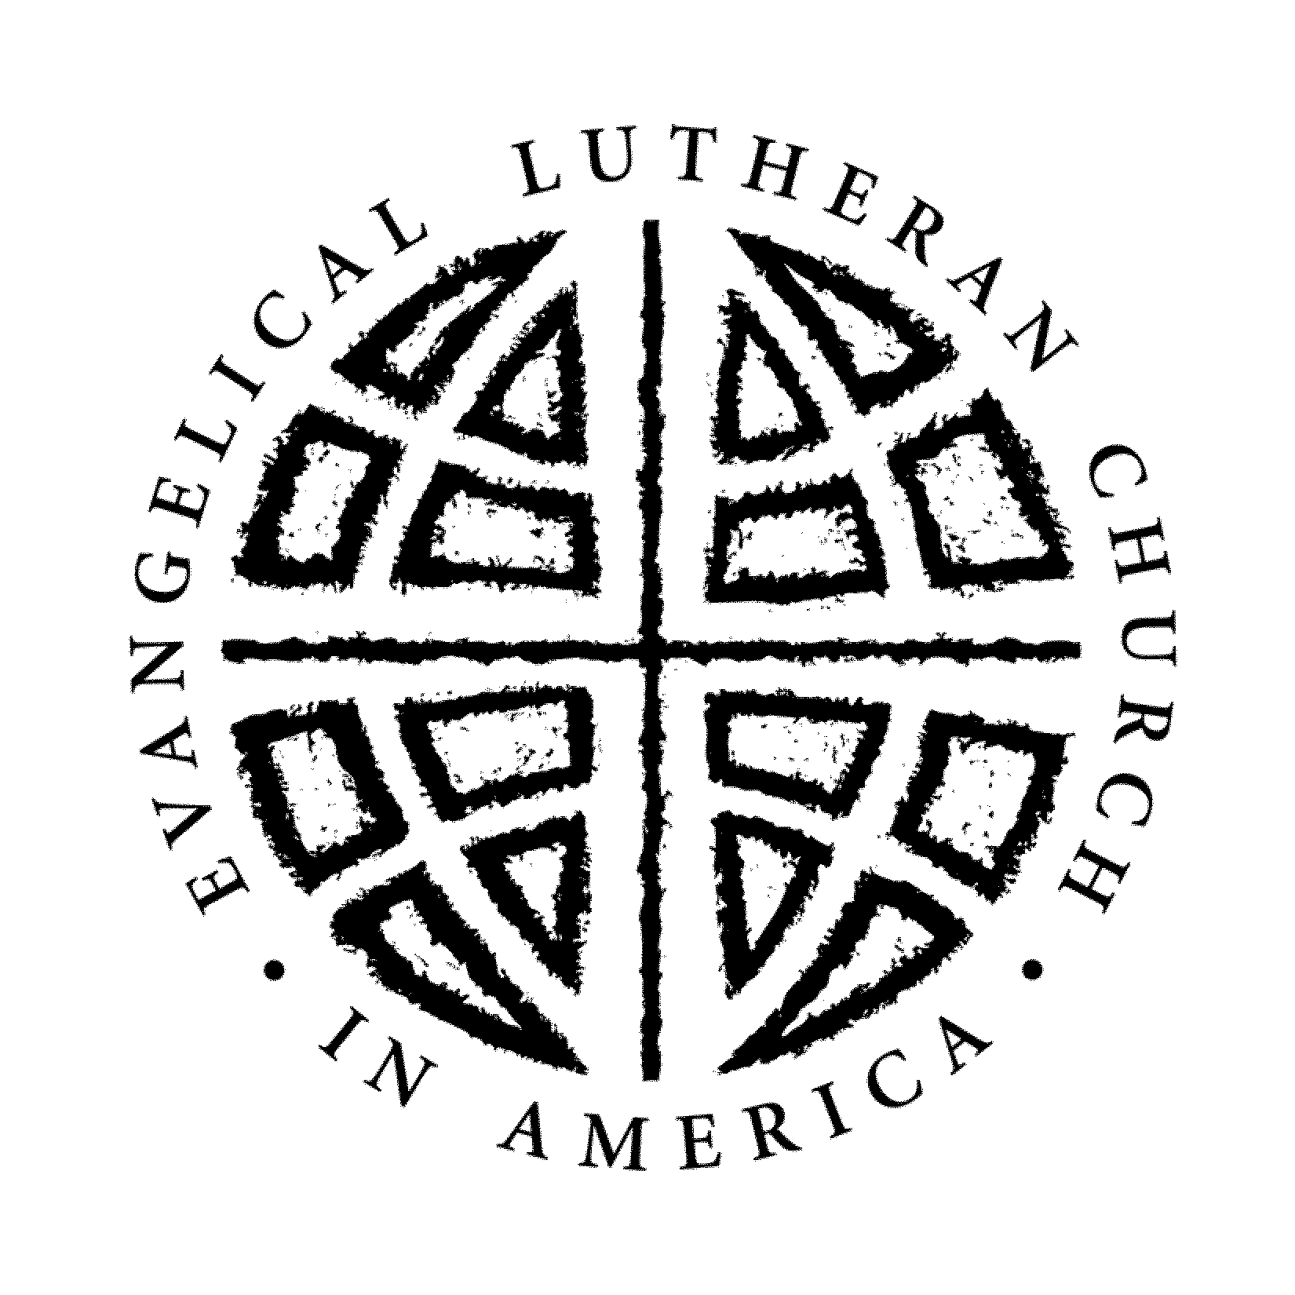IMMANUEL LUTHERAN CHURCH
Office: 419 E. Grove Street
Caledonia, Minnesota 55921
507-725-3123

February 1, 2024

Dear Immanuel Graduating Senior and family:

We are entering the time of year when you may be considering making application for furthering your education. Please be advised that at Immanuel Lutheran Church, you may make application to the “Immanuel Lutheran/Elmer & Doris Anderson Scholarship Award,” and the “Leland Schulze Scholarship Award.”

Application forms are enclosed, available online on our website at immanuelcaledonia.org under “Youth Resources”, or at the church office and are to be completed per the instructions included on the form. Also, suggestions for information to include in answering the questions are included.

We ask that you return your application form to the church office by Monday, April 1st.
The Scholarship Board will review the submitted applications and will contact you regarding an appointment (in person or via Zoom, to be determined) to visit with you about your application and postsecondary education plans.
If you have any questions, contact any of the Immanuel Scholarship Committee members:
Holly Becker 612-719-3721 gbecker1@acegroup.cc
Ashley Dress 317-626-1560 adress6126@gmail.com
Pam Schieber 507-724-5129 grandmap45g@gmail.com
Jan Klug 507-725-2070 bjklug76@gmail.com

Mike Schuldt 507-725-3926 mcschuldt60@gmail.com

Thank you.

Immanuel Lutheran Scholarship Committee

