Ninth Sunday after Pentecost
Immanuel Lutheran Church
July 26, 2026

Welcome to this place of praise and prayer. We gather today in celebration of the life, death and resurrection of Jesus Christ, as part of God’s family.
- We would appreciate having you sign our guest book so that we can remember your presence with us. Please note that in the ELW the page numbers are printed at the bottom of the page and hymn numbers are located at the top. The order of worship is outlined on the following pages.
- The offering reminds us that all of life is a gift of God. We are stewards of that gift. In response, a portion of our income is given as an act of worship to do God’s work in the world. Immanuel is a first-fruits congregation. That means that every Sunday when the offering is taken in, we give first to the mission and the ministry of the ELCA. We don’t wait to see if we can pay our bills before we give away for God’s mission. It is our hands doing God’s work, for the sake of the world our Lord loves.
- We serve Holy Communion on the first Sunday of the month and at all festivals. We offer an open invitation to all baptized believers to participate. It is our understanding that Christ offers his body and blood with the bread and wine to forgive sin and strengthen faith and life. If you receive communion in your home church, you are welcome to receive communion here.
- We have a toddler worship area in the middle-right section of our pews. This area is intended for children ages 0-3 accompanied by an adult(s) to sit during worship. Children 4K-6th Grade are welcome to join us for Sunday school during worship downstairs. This is a space for families to be fully engaged in worship, while providing quiet activities for young children to accommodate their natural need to move and be busy. Please follow posted guidelines for use of this space. Thank you!
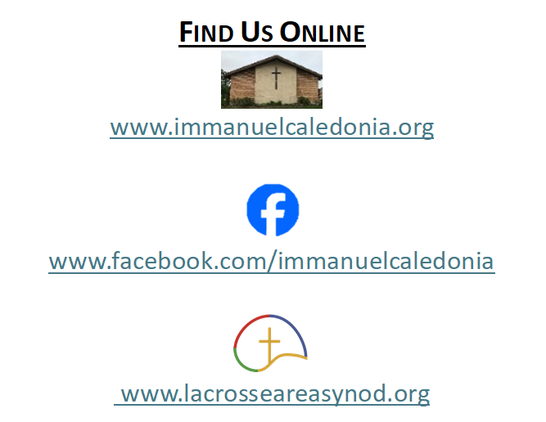
- We have accommodated seating available in the middle-left and the front-right sections of our pews. Please feel free to utilize this space for those who may need it!
Contact Information
Rev. Steven E. Meyer
pastormeyer@acegroup.cc
507-725-3123 or 507-459-7623 (cell)

Church Office: Sarah Klug
churchoffice@acegroup.cc
507-725-3123

Organist/Choir Director, Emily Riley
rileem01@gmail.com

Copyright permissions: Liturgical Text & Music; From Sundaysandseasons.com Copyright© 2026 Augsburg Fortress
Church Copyright License #23044886; Church Streaming License #23044893
GATHERING
The Holy Spirit calls us together as the people of God.

Prelude

Welcome And Worship Announcements
*Please note all bold text throughout the service are congregational responses

(Please stand as you are able)
Confession and Forgiveness
Blessed be the holy Trinity,☩ one God,
whose compassion endures forever.
Amen.
Let us confess our sin to God.
(Silence is kept for reflection)
Compassionate God,
we confess to you all our sins.
Our burden is heavy, and we cannot free ourselves.
In your mercy, call us back to you.
Your yoke is easy and your burden is light.
Restore us to dwell in your peace.
In Christ’s name we pray,
Amen.
Jesus says, “Come to me,
all you who are weary
and are carrying heavy burdens,
and I will give you rest.”
In the name of God,
Father, ☩ Son, and Holy Spirit,
your sins are forgiven.
Rest in God’s love.
Amen.

Gathering Hymn Gather Us In Vs. 1,2, & 4 #532

Greeting
The grace of our Lord Jesus Christ, the love of God, and the communion of the Holy Spirit be with you all.
And also with you.

Kyrie Page 165

Hymn of Praise Neither Death nor Life #622

Prayer Of The Day
Beloved and sovereign God, through the death and resurrection of your Son you bring us into your kingdom of justice and mercy. By your Spirit, give us your wisdom, that we may treasure the life that comes from Jesus Christ, our Savior and Lord. Amen.

Hymn (children come forward) Halle, Halle, Hallelujah #172

Word for Kids

WORD
God speaks to us in scripture readings, preaching, and song

First Reading: Genesis 29:15-28

Laban deceives Jacob by giving his older daughter, Leah, to Jacob in marriage instead of the promised younger daughter, Rachel. Because of his love for Rachel, Jacob agrees to work for Laban for an additional seven years so that he may also be married to her.

¹⁵ Laban said to Jacob, “Because you are my kinsman, should you therefore serve me for nothing? Tell me, what shall your wages be?” ¹⁶ Now Laban had two daughters; the name of the elder was Leah, and the name of the younger was Rachel. ¹⁷ Leah’s eyes were weak, but Rachel was graceful and beautiful. ¹⁸ Jacob loved Rachel, so he said, “I will serve you seven years for your younger daughter Rachel.” ¹⁹ Laban said, “It is better that I give her to you than that I should give her to any other man; stay with me.” ²⁰ So Jacob served seven years for Rachel, and they seemed to him but a few days because of his love for her.
²¹ Then Jacob said to Laban, “Give me my wife that I may go in to her, for my time is completed.” ²² So Laban gathered together all the people of the place and made a feast. ²³ But in the evening he took his daughter Leah and brought her to Jacob, and he went in to her. ²⁴ (Laban gave his maid Zilpah to his daughter Leah to be her maid.) ²⁵ When morning came, it was Leah! And Jacob said to Laban, “What is this you have done to me? Did I not serve with you for Rachel? Why then have you deceived me?” ²⁶ Laban said, “This is not done in our country—giving the younger before the firstborn. ²⁷ Complete the week of this one, and we will give you the other also in return for serving me another seven years.” ²⁸ Jacob did so and completed her week; then Laban gave him his daughter Rachel as a wife.

The Word of the Lord. Thanks be to God!

(Please stand as you are able)
Gospel Acclamation Lord, I Lift Your Name on High #857

Gospel Reading: Matthew 13:31-33,44-52

Throughout Matthew’s gospel, Jesus and his disciples proclaim the good news that “the kingdom of heaven is near!” Here, Jesus offers several brief parables that explore the implications of this announcement for people’s lives.

The holy gospel according to Matthew, chapter 13. Glory to you, O Lord.

³¹ [Jesus] put before [the crowds] another parable: “The kingdom of heaven is like a mustard seed that someone took and sowed in his field; ³² it is the smallest of all the seeds, but when it has grown it is the greatest of shrubs and becomes a tree, so that the birds of the air come and make nests in its branches.”
³³ He told them another parable: “The kingdom of heaven is like yeast that a woman took and mixed in with three measures of flour until all of it was leavened.”
⁴⁴ “The kingdom of heaven is like treasure hidden in a field, which a man found and reburied; then in his joy he goes and sells all that he has and buys that field.
⁴⁵ “Again, the kingdom of heaven is like a merchant in search of fine pearls; ⁴⁶ on finding one pearl of great value, he went and sold all that he had and bought it.
⁴⁷ “Again, the kingdom of heaven is like a net that was thrown into the sea and caught fish of every kind; ⁴⁸ when it was full, they drew it ashore, sat down, and put the good into baskets but threw out the bad. ⁴⁹ So it will be at the end of the age. The angels will come out and separate the evil from the righteous ⁵⁰ and throw them into the furnace of fire, where there will be weeping and gnashing of teeth.
⁵¹ “Have you understood all this?” They answered, “Yes.” ⁵² And he said to them, “Therefore every scribe who has become a disciple in the kingdom of heaven is like the master of a household who brings out of his treasure what is new and what is old.”

This is the gospel of our Lord. Praise to you, O Christ!

(Congregation may be seated)
Sermon

Hymn of the Day Be Thou My Vision #793

Apostles’ Creed Page 105
Or Inside Back Cover of Hymnal
Prayers of the People
The response to each prayer will be, “God of Grace,”
Congregations reply will be, “hear our prayer.”

Sharing of the Peace
The peace of Christ be with you always.
And also with you.
You are welcome to send a text or email to share peace with others.

Offering
(Offerings may be placed in the wooden offering box as you leave the sanctuary)

Offering Response Goodness Is Stronger than Evil #721

Offering Prayer
Loving God, we offer at your table the gifts of our hearts. Help us take heart in you and share freely of your love, so that all creation can taste your abundance. We ask this in the name of Jesus, through the Spirit abiding with us now and forever. Amen.

The Lord’s Prayer
Our Father, who art in heaven, hallowed be thy name, thy kingdom come, thy will be done, on earth as it is in heaven. Give us this day our daily bread. And forgive us our trespasses, as we forgive those who trespass against us. And lead us not into temptation but deliver us from evil. For thine is the kingdom, and the power, and the glory, for ever and ever. Amen.

SENDING
God Blesses Us and Sends Us in Mission for the World.

Benediction

Announcements

Sending Hymn The Reign of God, like Farmer’s Field Separate Insert

Dismissal
Go in peace. You are the body of Christ.
Thanks be to God.

Postlude

Thank you to today’s volunteers!
We would love to have your help during our worship service. Please sign up at the kiosk in the church narthex or on the church website under the sign-up link on the home page. Thank you!

